Name:____________________________________________ Date:________________ Period: _______
Quiz 1A – Circuits – (10 Points)
1) A motor (6 Ω), Fuse (10 Ω), and a Resistor (20 Ω) are wired to a 12 V battery. A single switch is wired into the circuit to control the power to ALL three devices simultaneously.
Draw the circuit diagram with all the above elements (battery, switch, motor, fuse, and resistor). Design the circuit such that each device gets 12 V. Use the same circuit symbols as PositivePhysics. (5 Points)

2) Three small bulbs are wired as shown below and connected to a 9V supply. The resistance in each bulb is 6 Ω.
a) Rank the brightness of the bulbs by putting >, <, = on the lines below. (2 Points)

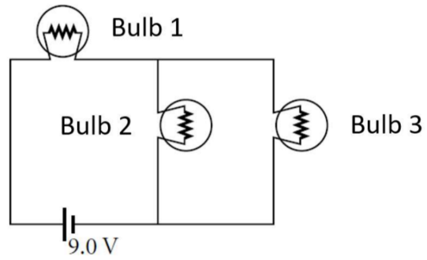
1 _____ 2 ______ 3

b) What is the current leaving the supply? (3 Points)

Name:____________________________________________ Date:________________ Period: _______
Quiz 1B – Circuits – (10 Points)
1) A Fuse (6 Ω), Resistor (20 Ω), and a Buzzer (10 Ω) are wired to a 12 V battery. A single switch is wired into the circuit to control the power to ALL three devices simultaneously.
Draw the circuit diagram with all the above elements (battery, switch, Fuse, Resistor, and Buzzer). Design it so that all three devices will run when the switch is closed and the battery will have the longest lifespan. Use the same circuit symbols as PositivePhysics. (5 Points)

2) Three small bulbs are wired as shown below and connected to a 9V supply. The resistance in each bulb is 6 Ω.
a) Rank the brightness of the bulbs by putting >, <, = on the lines below. (2 Points)


1 _____ 2 ______ 3

b) What is the current leaving the supply? (3 Points)

